- Create a comparative mind map illustrating the differences among AI, ML, DL, Generative AI, and LLMs based on learning approach, data requirements, computational complexity, outputs, and applications. Recommend the best technology for educational chatbots.

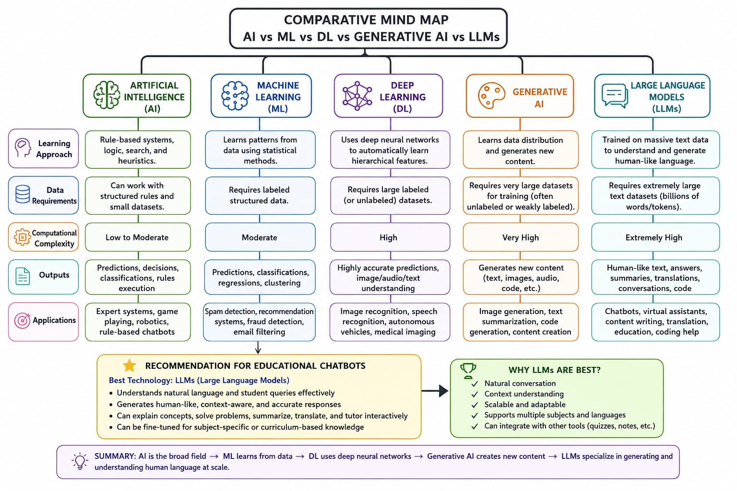

- Design a comprehensive mind map for the evolution of intelligent systems, beginning with Artificial Intelligence and progressing through Machine Learning, Deep Learning, Generative AI, and Large Language Models. Include key algorithms, applications, and relationships between each technology.

